**Part 1—Creating a Graphical User Interface (GUI)**

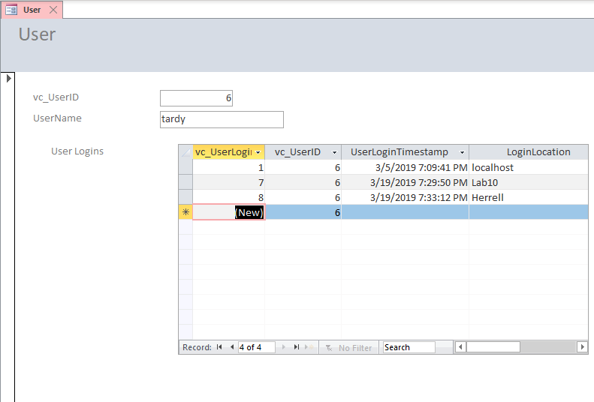

1. The software knew to grab the correct vc_UserLoginID because we told it to select the current user ID when adding a new record and we set it to default to the current datetime if there is no datetime entered.
2. It knew to use the vc_UserID that was selected in the main form for the vc_UserLogin in the sub form because of the foreign key relationship we programmed in MS Access at the beginning of the lab.
3. Pros: It doesn’t necessarily require an in-depth knowledge of SQL code to create/manage a database in MS Access. Also, it is easier to conceptualize queries and the relationships between tables with the user-friendly visual wizards in MS Access.

Cons: MS Access doesn’t import all the relationships previously established in SQL Server, so if someone unfamiliar with the database tries to move it to MS Access to manage it, they might not be able to re-create the correct relationships between tables. Also, if you add records via MS Access, you don’t have a record to re-enter the data that is added in the even that you have to modify your table structure like you would if you were to use SQL Server insert statements.

**Part 2—Using R to Connect to SQL Server**

